**DECLARATION**

We undersigned students of semester B.E in Electronics and Communication Engineering, BMS College of Engineering, Bangalore, hereby declare that the dissertation entitled “**AN OPEN SOURCE MINIATURE ROBOTIC DEVELOPMENT PLATFORM**”, embodies the report of our project work carried out independently by us under the guidance of Mrs. H.N. Latha, Assistant Professor, Electronics and Communication Engineering Department, BMSCE, Bangalore in partial fulfilment for the award of Bachelor of Engineering in Electronics and Communication from Visvesvaraya Technological University, Belgaum during the academic year 2017-2018.

We also declare that to the best of our knowledge and belief, any student has not submitted this project for the award of any other degree on earlier occasion.

Place: Bangalore

Date:

Aditya Bhat K Akshay U Hegde

1BM14EC001 1BM14EC005

Ashwin N Heethesh Vhavle

1BM14EC012 1BM14EC038

**B.M.S COLLEGE OF ENGINEERING**

(Autonomous College under VTU)

**Department of Electronics and Communication Engineering**

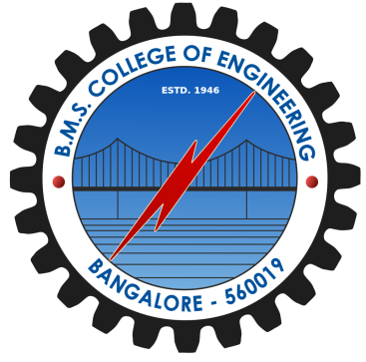

**CERTIFICATE**

This is to certify that the project entitled **“AN OPEN SOURCE MINIATURE ROBOTIC DEVELOPMENT PLATFORM”** is a bonafide work carried out by **Aditya Bhat K** (USN: 1BM14EC001), **Akshay U Hegde** (USN: 1BM14EC005) , **Ashwin N** (USN: 1BM14EC012) and **Heethesh Vhavle Naresh** (USN: 1BM14EC038) in partial fulfillment for the partial completion of PROJECT FOR COMMUNITY SERVICE - I [16EC7DCPW1] during the academic year 2017-2018.

**H.N. Latha Dr. G . Poornima Dr. K. Mallikharjuna Babu**

Assistant Prof., ECE, BMSCE HOD, ECE, BMSCE Principal, BMSCE

**External Examination:**  **Signature with Date:**

1.

2.

**DEDICATION**

**ABSTRACT**

**ACKNOWLEDGMENT**